1. **PURPOSE:**

To provide a guidance on good chromatographic practices.

1. **SCOPE:**

The procedure is applicable to all the HPLC/GC analysis in the Quality Control laboratory in Discovery Laboratories Pvt. Ltd.

1. **RESPONSIBILITY:**
   1. Analyst-QC is responsible to follow this SOP.
   2. Head-QC/Designee is responsible for ensuring implementation of this SOP.
   3. Head-QA/Designee is responsible for monitoring overall compliance of this SOP.
2. **DEFINITIONS:**

Nil

1. **PROCEDURE:**
   1. **Precautions :**
      1. Check and ensure the validity of calibration of the instrument before starting the analysis.
      2. Ensure that the analysis plan is available before starting the analysis.
      3. Verify the instrument usage log for the information on previous usage and flushing of the instrument after previous usage. If the instrument is not flushed, flush the system with appropriate solvents as per the procedure mentioned under ‘Flushing of HPLCs’ in this SOP.
      4. If normal phase solvents are used, ensure that the system is flushed immediately with flushing solvents compatible with the mobile phase used, followed by commonly used rinsing solvents like methanol, acetonitrile, water or a suitable mixture of these solvents.
      5. Before starting the analysis, ensure reservoirs meant for rinsing solvents, syringe washings are filled with appropriate solvents.
      6. Use only dedicated columns for the product for analysis.
      7. Ensure that the column is flushed after the previous usage.
      8. Allow the column/detector to stabilize sufficiently in the mobile phase before starting the injections.
      9. In case of gradient elution methods, stabilize the system with organic phase, initial gradient composition followed by blank injections if required until stable baseline is observed.
      10. Check and ensure that the waste collection bottles are emptied before starting analysis
      11. During the analysis all the analyst shall follow the do’s and don’ts mentioned below

|  |  |
| --- | --- |
| **Do's** | **Don'ts** |
| 1.      Always use cleaned and dried glassware for sample preparation | 1. Do not use semi dry glassware. |
| 2.      Rinse glassware with suitable diluent/mobile phase before weighing of samples, mentioned in MOA. | 2. Do not use other solvents for rinsing of   volumetric flask other than diluent mentioned in the respective MOA. |
| 3.      Ensure closing of lids after transferring of sample solution in to vials | 3   Do not interchange lids from one flask to other flasks like SST, Standard and sample solutions. |
| 4.      Always keep sample preparation area clean and tidy | 4   Do not prepare multiple samples at a time, to avoid contamination. |
| 5.      Ensure the labelling  properly for all  preparation and  vials | 5   Do not use any unlabeled preparations and vials for analysis. |
| 6.      Use same batch number of solvent/Diluent for standard and sample preparation | 6   Do not use different batch number of      solvent/Diluent for standard and sample      preparation |

* + 1. **Flushing of HPLC :**
       1. Selection of rinsing/washing solvents should be based the nature of mobile phase, diluents and sample under analysis.
       2. Rinsing/washing solvents should be replaced with suitable solvent before starting the analysis.
       3. If the instrument is not in use, keep the washing/rinsing solvent with a mixture of methanol: water in the ratio of 50:50
       4. Replace the washing solvents with fresh lots once in 2 days.
       5. Instruments should be flushed with, mobile phase at least for 30 minutes followed by appropriate washing solvent.
       6. If any buffers are used in the mobile phase, ensure that system is washed with water at least for 30 minutes after completion of analysis
       7. Switch over from organic solvent to aqueous by gradual increase the concentration of water. Finally wash and keep the system with methanol: water in the ratio of 50:50.
       8. Flush the system with hot water every 15 days and remove the suction filters and sonicate in 0.1N nitric acid for 15minutes after sonicate the filters in methanol.
  1. **Columns :**
     1. All HPLC / GC columns should be numbered and column log should be maintained.
     2. HPLC / GC columns should be subjected to performance check / suitability check prior to first usage to confirm the suitability to intended application of the column.
     3. Store columns in the respective storage area.
     4. Flush the HPLC columns after every analysis with appropriate solvents.
     5. Condition the GC column before and after every analysis.
  2. **Resolution Solution :** 
     1. In case where the resolution solution required for system suitability is to be stored for longer duration it shall be assigned a self-life based on the following.
     2. The resolution solution required for system suitability parameter as required by the respective STP on each days of the study.
     3. For the main analyse peak the difference of the area count on the day of preparation and at the end of the self-life shall not vary by 20% with respect to the limit area count.
     4. For the Impurity peak the difference in the area count on the day of preparation and at the end of the self-life shall not vary more than 20% with respect to the area count.
     5. The system suitability shall be established as per the STP, before proceeding with the analysis.
     6. Injection sequence shall be captured from the system as per the STP of respective product and shall be recorded.
     7. The injection sequence to be followed shall be as per the respective STP the following injection sequence may be used as guidelines.
     8. Blank-System Suitability (or-System Suit→Blank)→Impurity Standard→Standard→Sample.
     9. The system Suitability shall be valid for a maximum period of 24 hours. After about every 24 hours system Suitability.
     10. **Acceptance Criteria: The** stored resolution solution if used, shall meet the acceptance criteria on all the day of its use. Otherwise a freshly prepared resolution solution shall be injected.
  3. **Automated integration,** 
     1. **Assay Method :**
        1. Integrate all system suitability chromatograms within a sequence using appropriate integration parameters.
        2. Integrate all samples and corresponding standard chromatogram within a sequence using same integration parameters.
        3. Check each chromatogram within a sequence to ensure that integration is correct and consistent; then process it.
        4. If incorrect or inconsistent integration is noticed and effective corrections shall be made without resorting to manual integration, modify integration parameters as required. Save the processing method, reprocess as the chromatograms as required and save the data.
        5. In any chromatograms, set the vertical scale such that the highest analyte peak in the chromatogram is close to the 100% of full scale.
     2. **Related Compounds, Chromatographic purity and residual solvents**
        1. Integrate all system suitability chromatograms within a sequence using appropriate integration parameters
        2. Integrate sample chromatogram compared with blank.
        3. Check each chromatogram to ensure correct integration is obtained for all relevant peaks. Save the processing method and data as per figure 1,2,3,4,5
        4. Note: For related compounds, residual solvents and chromatographic purity, all peaks observed must be integrated unless any disregard limit is mentioned in the STP. Peak due to blank must be disregarded.
        5. Known peak must be integrated regardless of area.
        6. For printouts of sample chromatogram, set the vertical scale such that the analyte peak of lowest concentration is approximately 20% of the full scale, or suitable increased scale where integration is clearly visible.
        7. Note : It may be necessary to adjust the scaling so that all impurity peaks are fully on scale (i.e. Apexes of impurity peaks are not cut off).
        8. All sample and blank chromatograms in a sequence must be printed at the same scale, with a possible exception for baseline shift due to gradient changes. In such cases, it may be necessary to print additional plots with the same relative scaling but shifted up or down necessary to ensure all peaks are fully on scale.
        9. All resolution chromatogram printouts shall provide visibility of the lowest response peak.
        10. **Reintegration :**
            1. Certain situation may require reintegration of chromatogram. Examples include compound labeled wrongly, impurities having %area less than the disregard or discard limit (or) incompletely integrated chromatogram.
            2. In such cases, the concerned persons shall fill out a “Request for reintegration of the chromatogram of “HPLC/GC” and forward this to the head quality control or his Designee for approval along with processed chromatogram and reason for Reintegration of Chromatograms.
            3. Upon approval by the head of Quality control or Designee, the chromatograms shall be reintegrated with proper comment and kept along with original chromatograms and the approved request. The reintegrated chromatograms shall be reviewed by the reviewer.
        11. **Manual Integration :**
            1. Manual Integration should be performed only when necessary and supervisory concurrence as defined below.
            2. When Manual integration has been performed, this shall be clearly identified. The date and the analyst name shall appear on the quantitation and analysis report. The reason for the manual integration shall be indicated.
            3. QC Supervisor or Designee shall provide written indication on the manual integration chromatograms indicating that they provides concurrence that manual integration is appropriate under circumstances
        12. **Procedure for integration of typical peak pattern** 
            1. For quantitation, use baseline to baseline integration except for the patterns described below as shown in figure 1
            2. Split Peak to base line integration can be used for following peak patterns:

Over lapping peaks of approximately equal height as shown in (A) of figure 1.

Fused peak at the leading edge of a larger peak as shown in (B) of figure 1.

Shoulder on the leading edge of larger peak as shown in (D) of figure 1.

Peak partially overlapped at the leading edge of a large peak shown in (E) of figure 2.

Peak partially overlapped at the leading edge of a large peak shown in (E) of figure 2.

* + - * 1. Typically a smaller peak on the tailing edge of larger peak is skimmed. Use exponential skimming as shown in (C) Figure-1



|  |  |
| --- | --- |
| **Figure-1** | **Figure-2** |

* + - * 1. If narrow peaks are not detected or two or more peaks are detected as one, set width accurately to the half height width of the narrowest peak.
        2. If baseline is not reproducibly processed for the peaks in chromatograms, the valley to valley integration shall be enabled in processing method as indicated in **Figure -2**

|  |
| --- |
| **Figure-3** |

* + - * 1. To remove the irrelevant peaks generated at the start of analysis, set inhibit integration to the period from 0.01 minutes after the analysis start to the time slightly beyond the end of the peak. Remove negative peaks generated at the start of analysis in the same manner, as indicated in Figure-4

|  |
| --- |
| **Figure-4** |

* + - * 1. Irrelevant peaks generated during the analysis should be removed by using a time program as indicated in Figure-5



|  |
| --- |
| **Figure-5** |

* + - * 1. This parameters is the first derivative, used to allow the integration algoritham to distinuiguish the start and stop of peaks from baseline noise and drift. When setting the Threshold value graphically, you select a section of baseline. The recommended Threshold value is base on the highest first derivative value determined in that section of the chromatogram

The diagram below shows examples of how incorrect values for peak width and Threshold can effect the baseline

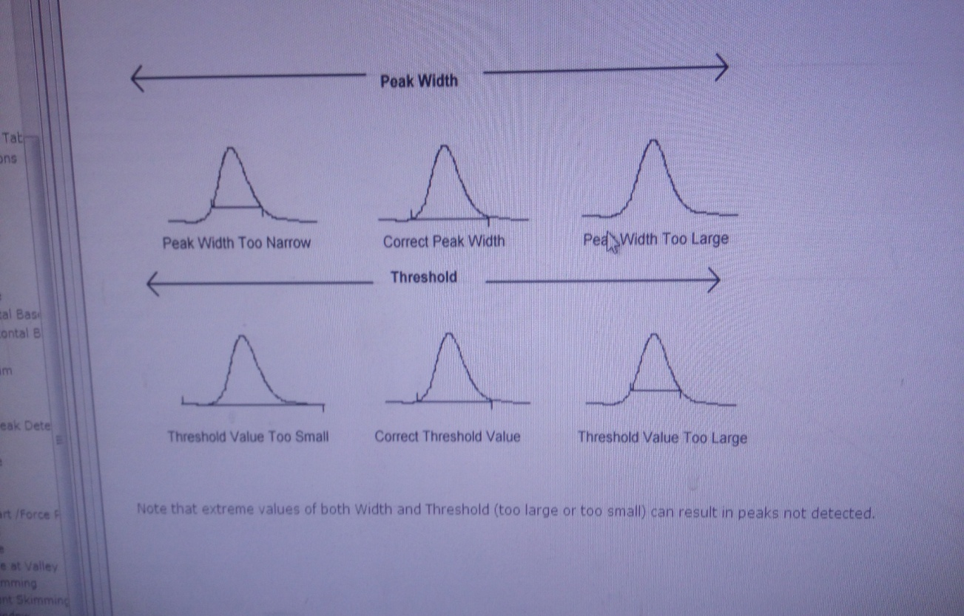

.

* 1. **System Suitability :**
     1. System suitability requirement shall be met as per STP Criteria, before proceeding with the test solution
     2. The system suitability shall be valid for maximum of 24 hours or as per the stability of analytical solution mentioned in the STP.
     3. If the initial system suitability fails, the analysis shall be repeated. The repeat decision shall be taken by QC Supervisor after reviewing the chromatograms and data invalidated.
     4. If the intermittent or bracketing system suitability fails to meet the acceptance criteria, the investigation shall be performed as per SOP No.SOP-QC-051-00 and according to that or LIR shall be raised.
     5. If there is a delay exceeding the run time in injecting the next sample, and if the system is not disturbed (Change in flow, wavelength or any other system parameters) the intermittent system suitability (i.e resolution / intermittent standard as mentioned in the STP) shall be done before proceeding with the analysis and updated sequence print shall be taken .
  2. **Ghost peak, broad peaks or humps** 
     1. Ghost peaks observed in sample chromatograms, a ghost peak is peak that appears at position where we do not except a peak. It is a component that shows up in the system and it may shows up anywhere in the chromatogram. Sometimes it is sharp peak, some time its broad peak or a hump and sometimes it is raising baselines.
     2. In HPLC the ghost peaks may arise due to –
        1. Un-retained solvents/ diluent peaks in reverse phase chromatography
        2. Formation of air bubble in system
        3. Diluent is different than the mobile phase
        4. Mobile phase contamination
        5. Sample preparation
        6. System contamination like
           1. Suction filter contamination
           2. Check valve contamination
           3. Flow cell contamination
        7. Column contamination like
           1. Elution of analytes retained from previous injection
           2. Clogging fits
     3. In gas chromatography (GC) the ghost peak may be due to
        1. The purity of the carrier gas
        2. Moisture traps contamination
        3. Memory effect due to back flash
        4. Contamination of injection port
        5. Injection port reactivity
        6. Septum’s, O-rings
        7. Analytical column bleed
        8. Shredding of graphite
        9. Column installation
        10. Contamination of sample from syringe, rinse vials, vial Septa /gloves etc.
     4. All the above shall be reported and investigated through incident or OOS procedure.
  3. **Chromatogram recording :**
     1. All chromatograms related to the analysis as per STP, shall be recorded and documented. The analysis and the reviewer shall sin and date each chromatogram.
     2. All the chromatogram which are not considered for analysis shall be stamped as DISREGRADED OR DISREGARDED shall be written on the chromatogram. The chromatogram shall be invalidated.
     3. For the HPLC system generated chromatograms, the following information shall be printed on each chromatogram.
        1. Instrument ID
        2. Sample ID
        3. Vial No.
        4. Injection volume
        5. Method Name
        6. Data file number
        7. User
        8. Date of acquired
        9. Processed by
        10. Printed On
        11. Instrument ID
        12. Analysed by & Date
        13. Checked by & Date
     4. The sample sequence print shall be attached with the analytical raw data.
     5. While preparing instrument method the extended needle wash shall be kept for syringe wash as and when required.
  4. **Printing the chromatograms :**
     1. Before starting any sequences on HPLC/GC the “Method Print” should be printed first and the parameters should be checked against the STP and verified by a second person.
     2. After verifying the “Method print”, “Sequence print” shall be printed and should be checked by the second person.
     3. Integration events should be printed and attached along with chromatograms. If same integration events are applicable for more than one chromatogram in series, one print attached to first chromatogram in series is sufficient. Attach next integration events print with the first chromatogram where integration events are changed.
     4. “Related substances and Residual solvents” chromatograms should be zoomed enough to visualize the smaller peaks.
     5. “Assay chromatograms” should be printed to visualize the peaks Apex clearly.
     6. If any unknown peaks are observed in the test solutions of residual solvents analysis, a deviation report should be raised and further investigated.

1. **FORMATS / ANNEXURE(S):**

Request for Reintegration of Chromatograms: QC055-FM117

1. **CHANGE HISTORY:**

| **Revision No.** | **Effective Date** | **Details of Revision** | **Ref CCF No.** |
| --- | --- | --- | --- |
| 00 | 05.08.2017 | New SOP Introduced | ---- |